Christy Gilliland

Daniel Abresch

Jack Amnuaysirikul

Krystina Poling

Melanie Meek

Patience Okereke

Tarig Abasit

Ziad Elharaoui

Science and Solutions

SWEN 670

Project Plan (UMGC City Team 1)

****VERSION HISTORY****

|  |  |  |
| --- | --- | --- |
| Version | Date | Description |
| 1.0 | 02/21/2020 | Initial Project Plan Release  Approved by client (Mr. Israel Del Toro) on 2/22/2020 |
| 2.0 | 03/21/2020 | Version includes feedback from Dr. Mir. |
| 2.1 | 04/19/2020 | Incorporates feedback from Dr. Mir. Updated Gantt charts to reflect changes that have occurred. |

**TABLE OF CONTENTS**

1. Project Summary 1

1.1. Scope and Objectives 1

1.2. Assumptions and Constraints 2

1.3. Project Deliverables 3

1.4. Project Schedule 3

1.5. References (Applicable to Project Plan) 5

1.6. Definitions 5

2. Project Organization 6

2.1. External Structure 6

2.2. Internal Structure 7

2.3. Roles and Responsibilities 7

3. Managerial Process Plan 9

3.1. Work Plan 9

4. Risk Management Plan 11

5. Technical Process Plan 13

5.1. Process Model 14

6. Methods, Tools, and Techniques 16

6.1. Development Collaboration 16

6.2. Software Architecture 17

6.3. Quality Assurance 19

6.4. Change Management 20

APPENDIX B – RACI MATRIX 22

APPENDIX C - COMMUNICATION MANAGEMENT PLAN 23

C1. Introduction 23

C2. Communications Management Approach 23

C3. Communications Management Constraints 24

C4. Stakeholder Communication Requirements 24

C5. Roles 25

C6. Project Team Directory 27

C7. Communication Methods and Technologies 28

C8. Communications Matrix 26

C9. Communication Flowchart 28

C10. Guidelines for Meetings 28

C11. Communication Standards 29

C12. Communication Escalation Process 30

C13. Glossary of Communication Terminology 31

APPENDIX D - CHANGE MANAGEMENT PLAN 33

D1. Introduction 33

D2. Project Constraints 33

D3. Stakeholders’ Roles and Responsibilities 34

D4. Definition of Change 34

D5. Change Management Process 35

****TABLE OF FIGURES****

Figure 1 - UMGC City Team 1 Project Organization 6

Figure 2 - Work Breakdown Structure 10

Figure 3 - Project Timeline 11

Figure 5 - Overview of Scrum Software Development Life Cycle (Created by Christy Gilliland) 15

Figure 6 - Trello Kanban Board 17

Figure 7 - Communication Flowchart 28

****TABLE OF TABLES****

*Table 1 – Project Deliverables* 9

Table 2 - Risk Management Matrix 18

Table 3 - Communications Matrix 26

Table 4 - Communication Escalation Process** 31

**UMGC CITY TEAM 1 - PROJECT PLAN**

# Project Summary

This section provides an overview of the project scope and expectations.

## Scope and Objectives

The scope of the UMGC City project is to build a free, open-source application that can be used by city officials to improve the usability of existing city web portals for their targeted audiences. The objective of the application is to enhance the user experience by helping them easily and intuitively locate applicable city ordinances for a predetermined list of frequently requested user inquiries (as determined by the city officials). In order to accomplish this goal, the application shall present the city officials with an interface to accept input of various use cases along with all the pertinent information that they think will benefit their intended audiences. The application shall process that data into appropriate tables that comprise a database. When the users visit the city web portal to search for specific ordinances, the database shall be called upon to produce appropriate output that is tailored to them in a tabular format. This generic, build-to-suit database infrastructure allows the application to be reused by any city.

The UMGC City teams, along with the DevOps team, will work closely with the customer, Israel Del Toro, to implement the database setup. In addition, the development teams shall tailor the application to deliver new pages and functionalities that are customized for the website of the City of Pasadena, California. Specifically, the UMGC City project teams will be delivering two interfaces: an interactive map/web-based interface (Team 1) and a ChatBot interface (Team 2). This project plan presents information applicable to the database setup and the map/web-based interface, whose tasks fall under UMGC City Team 1. UMGC City Team 2 shall use the same database setup that Team 1 built for the application.

## Assumptions and Constraints

It is assumed that the cities utilizing this application will appoint an official who is familiar with web-based applications. The official shall be educated in their respective city ordinances and be able to provide correct information for each desired use case.

It is assumed that the end users (city residents) will know how to use a web-based application and are familiar with the use of a map. Additionally, it is assumed that the user has a computer system which can handle the resources the application requires. Technical constraints for the system will be kept minimal. The interactive map requires an updated browser with JavaScript enabled. The application will operate using both server-side and client-side scripts. The application will be provided in English.

The application requires the user to have an updated browser and active internet connection. Chrome is the recommended and targeted browser for this application.

## Project Deliverables

The project deliverables for the UMGC City Team 1’s map/web-based interface include:

| **Due Date** | **Deliverables** |
| --- | --- |
| Milestone 1  February 23, 2020 | * Project Plan (this document) |
| Milestone 2  March 21, 2020 | * Software Requirements Specification (SRS) (Project Design) |
| Milestone 3  April 5, 2020 | * Software Test Plan (STP) |
| Milestone 4  April 26, 2020 | * Final application source code * Interface Design Documentation (Tutorial) |

*Table 1 – Project Deliverables*

## Project Schedule

The UMGC City Web-Based Map Interface project schedule is broken into four major milestones. See **APPENDIX A - UMGC CITY TEAM 1 PROJECT SCHEDULE** for the approved project schedule. A Gantt chart for each milestone is presented in the following four sub-sections.

### **Milestone 1**

The deliverable for milestone 1 includes the Project Plan.

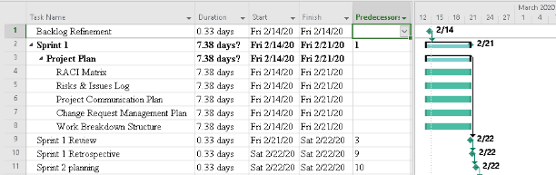

### Milestone 2

The deliverables for milestone 2 include the updated Project Plan, the Software Requirements Specification (SRS) and the Software Design Description (SDD).

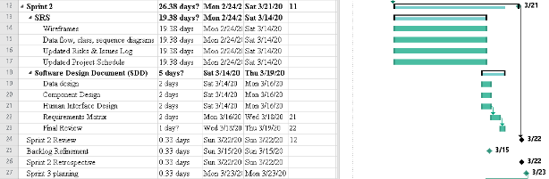

### Milestone 3

The deliverables for milestone 3 include code files and the Software Test Plan (STP). It will also include all updated files from previous milestones.

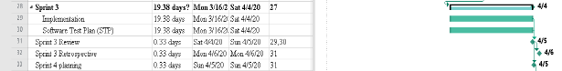

### Milestone 4

The deliverables for milestone 4 include the full code and test suite, the Interface Design Document and all updated files from previous milestones.

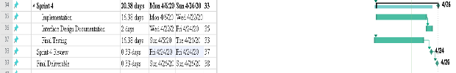

## 1.5. References (Applicable to Project Plan)

● IEEE Standard for Software Project Management Plans. IEEE Std 1058.1-1987, 31 Aug. 1988. Accessed via https://cours.etsmtl.ca/log792/private/restreint/IEEE_1058_Project_

Management_Plan.pdf

● https://learn.umuc.edu/d2l/le/content/444089/viewContent/16973490/View (Assignment Description)

● “Risk Mitigation Planning, Implementation, and Progress Monitoring.” The MITRE Corporation, 10 Apr. 2015, www.mitre.org/publications/systems-engineering-guide/acquisition-systems-engineering/risk-management/risk-mitigation-planning-implementation-and-progress-monitoring.

## Definitions

CI/CD

CSS

DevOps

HTML

PM

RACI Matrix

Continuous Integration/Continuous Delivery

Cascading Style Sheet

Development Operations

Hypertext Markup Language

Project Manager

(Responsible, Accountable, Consulted, Informed) Chart

SRS

STP

UMGC

UML

WBS

Software Requirements Specification

Software Test Plan

University of Maryland Global Campus

Unified Modeling Language

Work Breakdown Structure

# Project Organization

The organization of the UMGC City project is composed of two separate entities: a government client (the city of Pasadena represented by Israel Del Toro) and a private contractor (UMGC City Team 1). The roles of the entities are divided among external and internal personnel necessary to complete the project. This organizational paradigm mirrors a typical project management solution present in the real world. The external and internal structures are further described in the sections that follow.

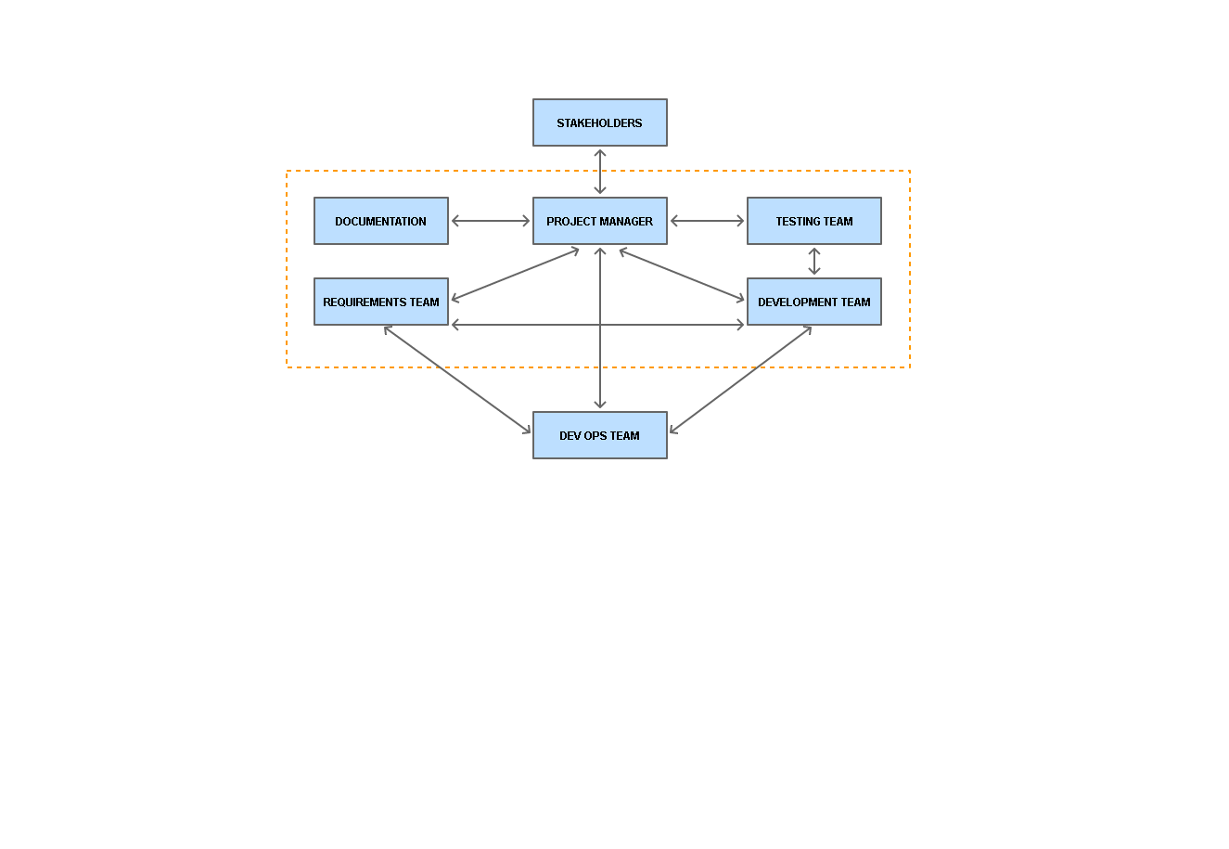

Figure 1 - UMGC City Team 1 Project Organization

## 2.1. External Structure

The external structure will consist of a project manager, Roy Gordon, who represents the government client to oversee and ensure successful implementation of the project. He will serve as the liaison between the customer, Israel Del Toro, and the private contractor’s team. Roy Gordon will serve the development team as a subject matter expert, making sure that all customer requirements are met and fulfilled in a timely manner. In addition, he can communicate any issues/concerns to the SWEN 670 professor, Dr. Mir Assadullah, who serves as the project advisor.

The DevOps team is external to UMGC City Team 1, but internal to the private contractor. The DevOps team and UMGC City Team 1 will work cohesively to design and develop the technical resources required to build the new application.

## 2.2. Internal Structure

The internal structure consists of members from UMGC City Team 1, representing the private contractor. The roles of the internal personnel are defined below.

## 2.3. Roles and Responsibilities

The project team consists of the following roles and responsibilities.

### 2.3.1. Project Manager (PM)

Christy Gilliland shall serve as the PM for UMGC City Team 1. As a liaison between the teams and all the stakeholders, the PM will communicate clearly and effectively any needs or concerns from the teams to affected stakeholders and vice versa. The PM coordinates with all team members to ensure the deliverables are completed on time and in accordance with all specifications. Furthermore, the PM organizes all group chat sessions, phase reports and student-professor communications.

2.3.2. **Software Requirements Analysts**

Jack Amnuaysirikul, Melanie Meek, Patience Okereke, Tariq Abasit, and Ziad Elharaoui shall fill the role of software requirements analysts for UMGC City Team 1. The software requirements analyst is responsible for evaluating the customer’s needs and converting them into specific software requirements. Furthermore, the analyst oversees the coordination of all necessary technical documentation in the project, including the Software Requirements Specification (SRS). By working closely with all the stakeholders, the analysts will establish the baseline of the project requirements with sufficient data expertise for the Project Plan, Software Development, and Testing.



### 2.3.3. Software Developers

Christy Gilliland, Daniel Abresch, Krystina Poling, Tariq Abasit, and Ziad Elharaoui shall assume the role of software developers. The responsibilities of software developers include, but are not limited to, the use of software development languages and tools to write, optimize, and maintain computer software for the project application. The developers shall exercise and follow the Agile Scrum framework to plan, design, build and deploy a relevant web-based map application. The final deliverables shall meet or exceed the customer’s requirements and expectations.

### 2.3.4. Software Testers

Daniel Abresch, Jack Amnuaysirikul, Krystina Poling, and Patience Okereke shall serve as software testers for UMGC City Team 1. The testers are responsible for reviewing software requirements and preparing appropriate test case scenarios. The test cases must be executed fully and iteratively to ensure software usability. By analyzing test results, proper reports are produced for the software development team to help eliminate errors, bugs, and other defects that can detract from the overall user experience of the software.

### 2.3.5. DevOps (External)

Johnny Lockhart and Anteneh Haile have volunteered to work for the DevOps Team whose role is to provide expert guidance regarding software architecture, database infrastructure, and other technical matters for the UMGC City project teams (Team 1 and Team 2). Specifically, the DevOps members will help guide the overall system architecture, provide code reviews, set up software repository and CI/CD pipeline, etc.

# Managerial Process Plan

The managerial process plan emphasizes the work schedule and task management needed to meet the agreed upon project goals. Please see **APPENDIX B – RACI MATRIX** for the RACI Matrix.

## Work Plan

The following subsections provide an overview of the tasks and schedule allocation for the duration of the project.



### Work Activities

The Work Breakdown Structure organizes the team’s work into manageable sections.

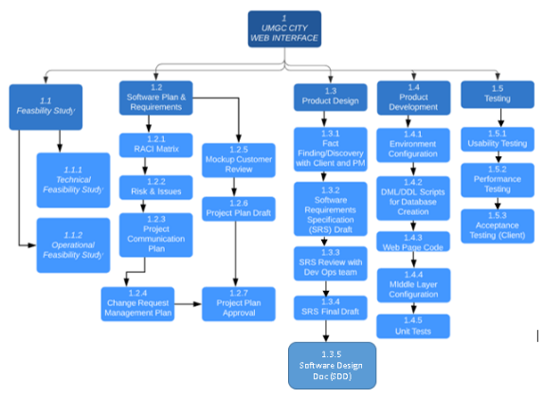

Figure 2 - Work Breakdown Structure

The following table shows the relation of tasks to the Software Development Life Cycle (SDLC).

|  |  |  |  |
| --- | --- | --- | --- |
| Task name | Category | Subtask | |
| Project Plan | Analysis | | Business analysis |
| Software Requirements Specification (SRS) | Design | Software Analysis | |
| Test Plan | Test | Test Design | |
| Final Deliverable | Code | Application Build | |

Table 2 - SDLC Tasks

### Schedule Allocation

The figure below illustrates the project schedule in a Gantt chart view. This chart highlights the dependency mapping between tasks. The chart shows the major project milestones along with delivery due dates for each project deliverable.

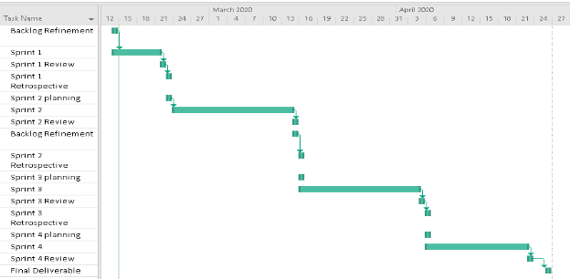

Figure 3 - Project Timeline

# Risk Management Plan

The purpose of the risk management plan is to identify, analyze, and prioritize risk factors. The plan will also include specific risk mitigation strategies. The risks are identified using a risk management matrix. Major risks are those that fall in red squares. Moderate risks are those that fall in yellow squares. Minor risks are those that fall in green squares.

Table 2 - Risk Management Matrix

|  |  |  |  |  |  |  |
| --- | --- | --- | --- | --- | --- | --- |
| **PROBABILITY** | **5** |  |  |  |  |  |
| **4** |  | **4** |  |  |  |
| **3** |  |  | **2** |  | **5** |
| **2** |  |  |  |  |  |
| **1** | **1** | **3** |  |  |  |
|  |  | **1** | **2** | **3** | **4** | **5** |
|  |  | **CONSEQUENCE** | | | | |

| **Risk ID** | **Description** | **Impact** | **Mitigation** |
| --- | --- | --- | --- |
| 1 | The application is not completed by deadline | Unable to deliver product to client on time | Risk acceptance – It is tolerated within course guidelines to transfer project to the next team(s). |
| 2 | Functions from both teams do not integrate well, if at all, with each other | Difficulty in utilizing the two applications as intended | Risk avoidance – The two teams have collaborated efforts to avoid delivering two applications that do not integrate well. |
| 3 | Testing encounters problems | Unable to deliver product to client on time | Risk acceptance – It is tolerated within course guidelines to transfer project to the next teams(s). |
| 4 | Infrastructure will not support multiple users | Cities will be limited to one city official user at a time | Risk acceptance – The application is designed for one registered city official to maintain the database for a city. |
| 5 | The application is unable to apply security measures that would be applicable for all city users. | Database integrity is compromised by unauthorized users | Risk avoidance – Security measures have been built into the application to prevent unauthorized access. |

Table 3 - Risk Management Matrix and Risk Legend for Matrix

The risks are assessed by a combination of the likelihood of occurrence (probability on a scale of 1 to 5) and the consequence (level of impact to project on a scale of 1 to 5). Risk 1 and 3 are categorized as green risks. Green risks are mitigated by watching and assuming the risk. The course structure accounts for projects being incomplete by the end of the semester. In the event Team 1 completes the project but is unable to fully test the application, the test plan will be sent to the course professor for transfer to future teams.

Risks 2 and 4 are categorized as yellow risks. Yellow risks are mitigated by avoiding, controlling, and/or transferring the risk to another stakeholder. In the event risk 2 occurs, the project will be turned over to the next project group for improvement. In the event risk 4 occurs, city officials will be advised ahead of time that cities can only have one user representative using the application.

Risk 5 is categorized as a red risk. Red risks are mitigated by avoiding, controlling, and/or transferring the risk to another stakeholder. Cities will be advised that the application should be used at their own risk and they must provide appropriate security measures to prevent unauthorized access.

# Technical Process Plan

The technical process plan will explain the process model being utilized as well as the tools, techniques, and methods to be used in the development of the software.

## Process Model

UMGC City Team 1 will be utilizing Scrum, which is a subset of the Agile Methodology for project management purposes. The team structure and project ceremonies are described below. Due to its iterative and incremental approach, Scrum provides rapid, yet flexible development of software including complex functions. In addition, Scrum facilitates a self-organizing team that promotes software productivity. Thus, it helps fulfill project tasks with short timelines throughout the software development life cycle.

Members of the team are defined as follows:

● Project Manager/Scrum Master: Christy Gilliland

● Developers: Daniel Abresch, Krystina Poling, Tarig Abasit, Ziad Elharaoui,

● Testers: Jack Amnuaysirikul, Melanie Meek, Patience Okereke

● Requirements Analysts: Melanie Meek, Patience Okereke

● DevOps Team: Johnny Lockhart, Anteneh Haile

● Stakeholders: Israel Del Toro, Mir Assadullah, Roy Gordon

● Customer: Israel Del Toro

● Product Owner: Roy Gordon

Below is a breakdown of the Scrum ceremonies that will take place throughout the life of the project.



Stakeholder Requirements

Initial Backlog

RELEASE

Figure 5 - Overview of Scrum Software Development Life Cycle (Created by Christy Gilliland)

### Sprint Planning



This ceremony is a one to two-hour time boxed event that occurs prior to the Sprint which requires the participation of the development team and the product owner. It helps in creating a smooth pathway for a successful sprint. At this meeting, the product backlog is prioritized, and the team commits to what can be accomplished within the sprint.

### Daily Scrum

This short Scrum ceremony is a daily event that requires participation of all Scrum team members to synchronize activities and give updates on the progress of the product. It is a way to ensure transparency and accountability across the team. Team answers the following questions during this daily update:

● What did you complete yesterday?

● What are you working on today?

● What are the blockers encountered?

### Sprint Review

This Scrum ceremony is held to inspect progress made during an increment and make changes to the Product Backlog. The team demos what they achieved in the sprint and gets feedback from the stakeholders to create a plan for improvements to be enacted during the subsequent Sprint. The participants are the development team, other teams involved in the project and the stakeholders.

### Sprint Retrospective

Scrum seeks continuous improvement and the retrospective is a method to make sure that the product and development culture is constantly improving. The sprint retrospective is used by the development team to identify what they did well and what didn’t go as planned so improvements can be made for the next sprint. It occurs at the end of a sprint, after the review, and is usually an hour in duration. The retrospective includes the development team and product owner.

# Methods, Tools, and Techniques

In order to establish a uniform standard within the project team, the following tools will be utilized during project development:

## Development Collaboration

● Issue Tracking: Trello will be used to track project stories, issues, and tasks throughout the project lifecycle using a Kanban-style board of 4 swim lanes: Backlog, To Do, Doing, and Done.

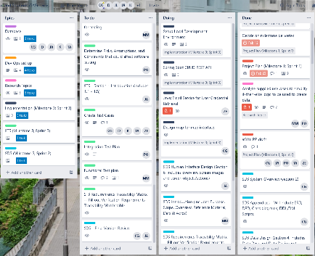

Figure 6 - Trello Kanban Board

● Product Documentation: Google Docs will be utilized to create appropriate project documentation.

● Instant Messaging: Google Hangout will be utilized for instant messaging communication to discuss roadblocks and pending work.

● Audio/Video Conferencing: Zoom will be used for audio communication between the team members. Team meetings and Scrum ceremonies will be performed using Zoom.

● The team has implemented a Project Communication Plan to guide all communication between team members during the life of the project. Please see **APPENDIX C - COMMUNICATION MANAGEMENT PLAN** for the full Project Communication Plan.

## 6.2. Software Architecture

* Design, modeling and prototyping artifacts:
  + Wireframes: Pencil will be used to create wireframes of web pages before the actual web code development starts.
  + Entity Relationship Diagrams: Visual Paradigm and/or ArgoUML will be utilized to create ERD diagrams.
  + Class Diagrams: Visual Paradigm and/or ArgoUML will be utilized to create UML diagrams.
* Technical Documentation: Microsoft Word will be used to write technical documents.
* Development and Build Automation:
  + IntelliJ, Visual Studio Code, and PyCharm IDE will be utilized to develop and edit system code.
  + Configuration Management: Configurations that are environment specific will be stored in configuration files as opposed to being hard coded in the system. Database connection strings, endpoint URLs, passwords, etc. must be stored in the application config file.
* Code management:
  + Source Control: Git will be the source control where all the code base lives. It is a distributed version control system.
  + Code Repository: Github will be used to host the code base.
* Database development
  + Database RDBMS: PostgreSQL will be the relational database management system used to manage data.
* Web Development:
  + Web Technology: Angular app-design framework and development platform will be used for creating an efficient and sophisticated single-page application. The Angular framework will be implemented using the following web technologies: HTML5, JavaScript (specifically Typescript), and Bootstrap CSS Framework.
* Back-end Development:
  + Integrated Development Environment: IntelliJ IDEA and PyCharm will be used to develop the application code.
  + Platform: Java SE 11 (LTS) for all major system processes and Python for batch scripts as they relate to automated data entry.
  + Logging: Log4j logging library will be used to log a debug or error message within the back-end system.

● Build automation: Biweekly scheduled deployments will be performed using Jenkins.

● Package Manager: Maven will be used to manage project dependencies.

● MVC framework: SpringBoot will be used to create the Spring MVC application.

## Quality Assurance

* Unit Testing: JUnit will be used to create unit tests to test the individual functions of the code.
* Code Reviews: Code reviews will be performed by peer developers to ensure the code developed is of good quality.
* Functional Testing: This testing will be done manually by the testing team to verify that the web pages are developed according to the requirements.
* Automated Regression Testing: Selenium will be used for regression testing to ensure newly developed code does not break existing functionality.
* Acceptance Testing: Acceptance testing will be performed by the client after final product delivery. Product acceptance is acquired through agreement from the customer that the application meets the defined requirements and specifications from the SRS. Results of acceptance testing will be reported back to Professor Mir Assadullah.

## Change Management

Please refer to **APPENDIX D - CHANGE MANAGEMENT PLAN** for the Change Management Plan.

|  |  |  |  |  |
| --- | --- | --- | --- | --- |
| **APPENDIX A - UMGC CITY TEAM 1 PROJECT SCHEDULE** | | | | |
|  |  | |  |  |
| **Date** | | **Time** | **Meeting** | **Attendees** |
| 2/14 | 9 PM EST | | Backlog Refinement | Required: Christy Gilliland, Roy Gordon |
| Optional: Team members |
| 2/22 | 12 PM EST | | Sprint 1 Review | Required: Christy Gilliland, Team members |
| Optional: Roy Gordon |
| 2/23 | 12 PM EST | | Sprint 1 Retrospective and Sprint 2 Planning | Required: Christy Gilliland, Team members |
| Optional: Roy Gordon |
| 3/15 | 12 PM EST | | Sprint 2 Review and Backlog Refinement | Required: Christy Gilliland, Roy Gordon |
| Required: Team members |
| 3/16 | 9 PM EST | | Sprint 2 Retrospective and Sprint 3 Planning | Required: Christy Gilliland, Team members |
| Optional: Roy Gordon |
| 4/05 | 12 PM EST | | Sprint 3 Review | Required: Christy Gilliland, Roy Gordon |
| Required: Team members |
| 4/06 | 9 PM EST | | Sprint 3 Retrospective and Sprint 4 Planning | Required: Christy Gilliland, Team members |
| Optional: Roy Gordon |
| 4/23 | 9 PM EST | | Sprint 4 Review | Required: Christy Gilliland, Roy Gordon |
| Required: Team members |

Acceptance received by the product owner on February 13th, 2020. 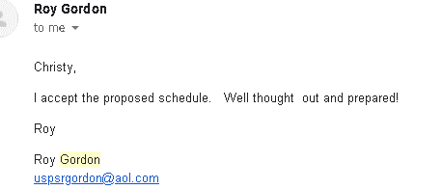

# 

# APPENDIX B – RACI MATRIX

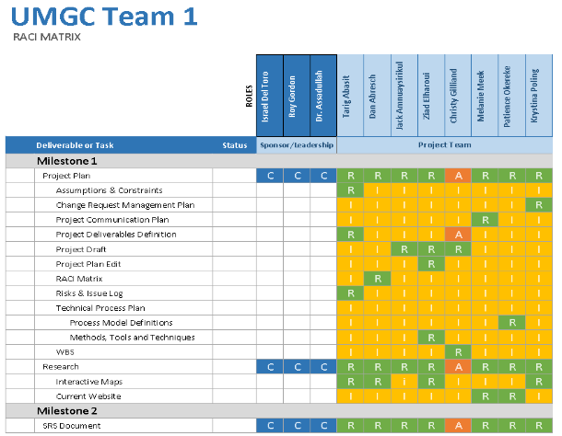

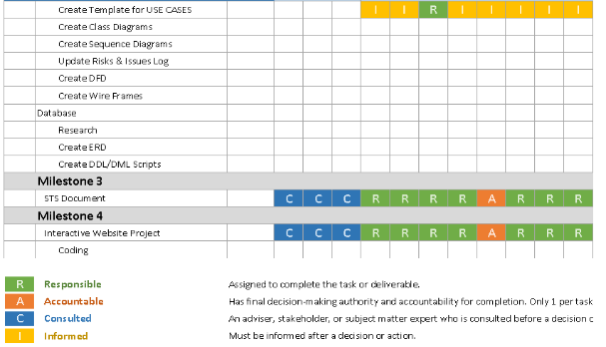

# APPENDIX C - COMMUNICATION MANAGEMENT PLAN

## C1. Introduction

This Communications Management Plan sets the communications framework for this project. It will serve as a guide for communications throughout the life of the project and will be updated as communication needs change. This plan identifies and defines the roles of persons involved in this project, a communications matrix that maps the communication requirements of this project and an in-depth guide for conducting meetings. Lastly, the project team directory is included to provide contact information for all stakeholders directly involved in the project.

## C2. Communications Management Approach

The Project Manager will take a proactive role in ensuring effective communications on this project. The communications requirements are documented in the Communications Matrix presented in this document. The Communications Matrix will be used as the guide for what information to communicate, who is to do the communicating, when to communicate it and to whom to communicate.

Updates or changes may be required as the project progresses, or changes are approved. Changes or updates may be required due to changes in personnel, scope, budget, or other reasons. Additionally, updates may be required as the project matures, and additional requirements are needed. The project manager is responsible for managing all proposed and approved changes to the communications management plan. Once the change is approved, the project manager will update the plan and supporting documentation and will distribute the updates to the project team and all stakeholders. This methodology is consistent with the project’s Change Management Plan and ensures that all project stakeholders remain aware and informed of any changes to communications management.

## C3. Communications Management Constraints

All project communication activities will occur within the project’s approved budget, schedule, and resource allocations. The project manager is responsible for ensuring that communication activities are performed by the project team and without external resources which will result in exceeding the authorized budget. Communication activities will occur in accordance with the frequencies detailed in the Communication Matrix in order to ensure the project adheres to schedule constraints. Any deviation of these timelines may result in excessive costs or schedule delays and must be approved by the project sponsor.

## C4. Stakeholder Communication Requirements

As part of identifying all project stakeholders, the project manager will communicate with each stakeholder in order to determine their preferred frequency and method of communication. This feedback will be maintained by the project manager in the project’s Stakeholder Register. Standard project communications will occur in accordance with the Communication Matrix. However, depending on the identified stakeholder communication requirements, individual communication is acceptable and within the constraints outlined for this project.

In addition to identifying communication preferences, stakeholder communication requirements must identify the project’s communication channels and ensure that stakeholders have access to these channels. If project information is communicated via secure means or through internal company resources, all stakeholders, both internal and external, must have the necessary access to receive project communications.

Once all stakeholders have been identified and communication requirements are established, the project team will maintain this information in the project’s Stakeholder Register and use this, along with the project communication matrix as the basis for all communications.

## C5. Roles

**Project Sponsor**

The project sponsor is the champion of the project and has authorized the project by signing the project charter. This person is responsible for the funding of the project and is ultimately responsible for its success. Since the Project Sponsor is at the executive level, communications should be presented in summary format unless the Project Sponsor requests more detailed communications. The project sponsor is Dr. Mir Assadullah.

**Key Stakeholders**

Normally Stakeholders include all individuals and organizations who are impacted by the project. For this project we are defining a subset of the stakeholders as Key Stakeholders. These are the stakeholders with whom we need to communicate with and are not included in the other roles defined in this section. The Key Stakeholders includes executive management with an interest in the project and key users identified for participation in the project. The key stakeholders are identified as Mr. Israel Del Toro, Mr. Gordon, and Dr. Assadullah.

**Change Control Board**

The Change Control Board is a designated group that reviews technical specifications and authorizes changes within the organization’s infrastructure. Technical design documents, user impact analysis and implementation strategies are typical of the methods of communication this group requires. The Change Control Board for this project formally consists of the project manager (Christy Gilliland), the technical lead (Krystina Poling), and a DevOps team member (Johnny Lockhart).

**Client**

The client for this project is the City of Pasadena. As the customer who will be accepting the final deliverables of this project, the person shall be informed of the project status including potential impacts to the schedule for the final deliverable or the product itself.

**Project Manager**

The Project Manager has the overall responsibility for successful execution of the project. The Project Manager manages day-to-day resources, provides project guidance and monitors and reports on the project metrics as defined in the Project Plan. As the person responsible for the execution of the project, the Project Manager is the primary communicator for the project, distributing information according to this Communications Management Plan. The Project Manager is Christy Gilliland.

**Project Team**

The Project Team is comprised of all persons who have a role performing work on the project. The Project Team needs to have a clear understanding of the work to be completed and the framework in which the project is to be executed. Since the Project Team is responsible for completing the work for the project, they play a key role in creating the Project Plan including defining its schedule and work packages. The Project Team requires a detailed level of communications which is achieved through day-to-day interactions with the Project Manager and other team members along with weekly team meetings. The list of project team members can be found in the Project Team Directory table below.

**Technical Lead**

The Technical Lead is a person on the Project Team who is designated to be responsible for ensuring that all technical aspects of the project are addressed and that the project is implemented in a technically sound manner. The Technical Lead is responsible for all technical designs, overseeing the implementation of the designs and developing as-build documentation. The Technical Lead requires close communications with the Project Manager and the Project Team. The Technical Lead is Krystina Poling.

## C6. Project Team Directory

The following table presents contact information for all personnel identified in this communications management plan. The email addresses and phone numbers in this table will be used to communicate with these people.

|  |  |  |  |
| --- | --- | --- | --- |
| **Role** | **Name** | **Organization/**  **Department** | **Email** |
| **Project Manager** | Christy Gilliland | UMGC City Team 1  PMO | [thegillfam@gmail.com](mailto:thegillfam@gmail.com) |
| **Technical Leads/Developers** | Ziad Elharaoui  Krystina Poling | UMGC City Team 1  IT | [ziad.elh@gmail.com](mailto:ziad.elh@gmail.com)  [krystina627@gmail.com](mailto:krystina627@gmail.com) |
| **Developer** | Tarig Abasit | UMGC City Team 1  IT | [Tabasit@student.umuc.edu](mailto:Tabasit@student.umuc.edu) |
| **Developer** | Daniel Abresch | UMGC City Team 1  IT | [danabresch@yahoo.com](mailto:danabresch@yahoo.com) |
| **Requirements Analyst** | Melanie Meek | UMGC City Team 1  Business Analysis | [mmeek87@gmail.com](mailto:mmeek87@gmail.com) |
| **Requirements Analyst** | Patience Okereke | UMGC City Team 1  Business Analysis | [patie.okereke@gmail.com](mailto:patie.okereke@gmail.com) |
| **Tester** | Jack Amnuaysirikul | UMGC City Team 1  Quality Assurance | [jamnuayswork@gmail.com](mailto:jamnuayswork@gmail.com) |

Table 4 – Personnel in Communications Management Plan

## C7. Communication Methods and Technologies

The Project Team will determine, in accordance with The City of Pasadena’s organizational policy, the communication methods and technologies based on several factors to include: stakeholder communication requirements, available technologies (internal and external), and organizational policies and standards.

The City of Pasadena maintains a SharePoint platform within the PMO which all projects use to provide updates, archive various reports, and conduct project communications. This platform enables senior management, as well as stakeholders with compatible technology, to access project data and communications at any point in time. SharePoint also provides the ability for stakeholders and project team members to collaborate on project work and communication.

For stakeholders who do not have the ability to access SharePoint, a web site will also be established for the project. Access to the website will be controlled with a username and password. Any stakeholders identified who are not able to access SharePoint will be issued a unique username and password in order to access the web site. The Project Manager is responsible for ensuring all project communications and documentation are copied to the web site and that the content mirrors what is contained on the SharePoint platform.

The UMGC maintains software licenses for MS Project software. All project teams are responsible for developing, maintaining, and communicating schedules using this software. Gantt Charts are the preferred format for communicating schedules to stakeholders. The project schedule will be maintained on both Google Drive and the UMGC City Team 1 forum.

All project communication and documentation, in addition to being maintained on the Google Drive and the UMGC City Team 1 forum, will be archived on the internal City of Pasadena shared drive which resides in the PMO program directory.

## C8. Communications Matrix

The following table identifies the communications requirements for this project.

Table 3 - Communications Matrix

| **Communication Type** | **Objective of Communication** | **Medium** | **Frequency** | **Audience** | **Owner** | **Deliverable** | **Format** |
| --- | --- | --- | --- | --- | --- | --- | --- |
| Sprint Planning | Team meets and decides what is needed to complete sprint | * Conference Call | Beginning of each sprint | * Project Team * PMO | Project Manager | * Agenda * Meeting Minutes | * Soft copy archived on Team forum on UMGC site and Google Drive |
| Daily Stand Up | Quick review of what each member of project team is working on | * Google Document | Daily | * Project Team * PMO | Project Team | * Tasks for the day | * Soft copy archived on Google Drive |
| Sprint Review | Demonstrate work completed in iteration, and get immediate feedback from project stakeholders | * Conference Call | End of each sprint/milestone | * Project Team * PMO * Project Stakeholders * Project Sponsor | Project Manager | * Agenda * Meeting Minutes | * Soft copy archived on Team forum on UMGC site and Google Drive |
| Sprint Retrospective | Continuous improvement opportunity for a Scrum team to review its process (approaches to performing Scrum) and to identify opportunities to improve it | * Conference Call | End of each iteration | * PMO * Project Team | Project Manager | * Slide updates * Project schedule | * Soft copy archived on Team forum on UMGC site and Google Drive |
| Informal Updates | Report the status of the project including activities, progress, costs and issues. | * Email * Google Hangouts | As needed | * Project Team * PMO | Project Manager | * Project Status Report * Project schedule | * Soft copy archived on Google Hangouts/email |
| Project Status Reports | Report the status of the project including activities, progress, costs and issues. | * Email | Weekly | * Project Team * PMO * Project Stakeholders   Project Sponsor | Project Manager |  | * Soft copy archived on Google email |

## C9. Communication Flowchart

The communication flowchart below is created to aid in project communication. This flowchart provides a framework for the Project Team to follow for this project. However, there may be occasions or situations which fall outside of the communication flowchart where additional clarification is necessary. In these situations, the Project Manager is responsible for discussing the communication with the Project Sponsor and making a determination on how to proceed.

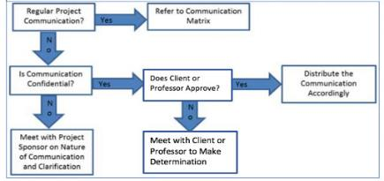

Figure 7 - Communication Flowchart

## C10. Guidelines for Meetings

**Meeting Agenda**

Meeting Agenda will be distributed 1 business day in advance of the meeting. The Agenda should identify the presenter for each topic along with a time limit for that topic. The first item in the agenda should be a review of action items from the previous meeting.

**Meeting Minutes**

Meeting minutes will be distributed within 2 business days following the meeting. Meeting minutes will include the status of all items from the agenda along with new action items.

**Action Items**

Action Items are recorded on the Trello Project Backlog in the form of cards. Action items will include both the action items along with the owner of the action items. Meetings will start with a review of the status of all action items from previous meetings and end with a review of all new action items resulting from the meeting. The review of the new action items will include identifying the owner for each action item.

## C11. Communication Standards

For this project, UMGC City Team 1 will utilize standard formats and templates for all formal project communications. Formal project communications are detailed in the project’s communication matrix and include:

* Kickoff Meeting – Project Team will utilize UMGC City Team 1 standard templates for meeting agenda and meeting minutes. Additionally, any slides presented will use the UMGC City Team 1 standard slideshow template.
* Project Team Meetings – Project Team will utilize UMGC City Team 1 standard templates for meeting agenda and meeting minutes. Additionally, any slides presented will use the UMGC City Team 1 standard slideshow template.
* Technical Design Meetings - Project Team will utilize UMGC City Team 1 standard templates for meeting agenda and meeting minutes. Additionally, any slides presented will use the UMGC City Team 1 standard slideshow template.
* Monthly Project Status Meetings - Project Team will utilize UMGC City Team 1 standard templates for meeting agenda and meeting minutes. Additionally, any slides presented will use the UMGC City Team 1 standard slideshow template.
* Project Status Reports – Project Team will utilize UMGC City Team 1 standard templates for meeting agenda and meeting minutes. Additionally, the standard project status report document, available on the share drive, will be used to provide project status.
* Informal project communications should be professional and effective but there is no standard template or format that must be used.

## C12. Communication Escalation Process

Efficient and timely communication is the key to successful project completion. As such, it is imperative that any disputes, conflicts, or discrepancies regarding project communications are resolved in a way that is conducive to maintaining the project schedule, ensuring the correct communications are distributed, and preventing any ongoing difficulties. In order to ensure that project stay on schedule and issues are resolved, UMGC City Team 1 will use its standard escalation model to provide a framework for escalating communication issues. The table below defines the priority levels, decision authorities, and timeframes for resolution.

Table 4 - Communication Escalation Process**

| **Priority** | **Definition** | **Decision Authority** | **Timeframe for Resolution** |
| --- | --- | --- | --- |
| Priority 1 | Major impact to project or business operations. If not resolved quickly, there will be a significant adverse impact to revenue and/or schedule. | Mr. Del Toro or Professor | Within one business day |
| Priority 2 | Medium impact to project or business operations which may result in some adverse impact to revenue and/or schedule. | Project Sponsor | Within one business day |
| Priority 3 | Slight impact which may cause some minor scheduling difficulties with the project but no impact to business operations or revenue. | Project Manager | Within two business days |
| Priority 4 | Insignificant impact to project but there may be a better solution. | Project Manager | Work continues and any recommendations are submitted via the project change control process |

** NOTE: Any communication including sensitive and/or confidential information will require escalation to Client level or higher for approval prior to external distribution.

## C13. Glossary of Communication Terminology

|  |  |
| --- | --- |
| **Term** | **Definition** |
| Communication | The effective sending and receiving of information. Ideally, the information received should match the information sent. It is the responsibility of the sender to ensure this takes place. |
| Stakeholder | Individuals or groups involved in the project or whose interests may be affected by the project’s execution or outcome. |
| Communications Management Plan | Portion of the overall Project Management Plan which details how project communications will be conducted, who will participate in communications, frequency of communications, and methods of communications. |
| Escalation | The process which details how conflicts and issues will be passed up the management chain for resolution as well as the timeframe to achieve resolution. |

*Table 7 – Communication Terminology*

# APPENDIX D - CHANGE MANAGEMENT PLAN

## D1. Introduction

The UMGC City Project will follow a hybrid change management approach that will be a combination between the ridged traditional approach and the flexible Agile change management approach. The purpose of the UMGC City Project’s change management plan is to set expectations for how changes will be managed based on project constraints, define what constitutes a change, define each stakeholders’ role and responsibilities, and finally explain the steps that each stakeholder must follow to have a change implemented.

## D2. Project Constraints

The UMGC City Project has two major constraints, these being schedule and budget. The implementation of the UMGC City Project is centered on Agile Principles and therefore will remain as flexible as possible to changing requirements. However, as change is managed during the project, the two main driving constraints will receive overriding consideration.

The project has a strict schedule constraint, and therefore must be kept on a tight schedule in order to adhere to the project’s mandated completion date. In addition to the strict deadline being imposed on the project team it will also need to remain completely cost free, as the project has no budget. To be able to satisfy the customer, the project constraints, and utilize the benefits provided by Agile, the change management board will accept all change requests into its change management process up until the point the change effects a requirement that has already been developed and marked as complete. Once the requirement is code complete it will be too late at that point for a rework to be considered because the risk to the project’s completion deadline will be too great.

## D3. Stakeholders’ Roles and Responsibilities

Change Manager/ Project Manager: Christy Gilliland

* The change manager will be responsible for the overall change process of the project to ensure that the project’s change management policies and procedures are followed. The primary responsibilities include, keeping change management log up-to-date, tracking and facilitating timely evaluation decisions, setting up change board meetings when necessary, and communicating any changes to stakeholders.

Change Control Board (CCB): All Members of the Project Team

* The Change Control Board will be composed of lead members of the project team and the group as a whole will act as an advisory committee. The board members’ main responsibilities include evaluating the change request for the purpose of assessing risk and impact levels, determining priority level, and providing any alternative solutions or suggestions. However, the Change Manager is responsible for the final review and ensuring at least one of the main stakeholders sign off on the approval or rejection of the requested change.

Change Requestor (Stakeholders)

* This can be any person from the project team who initiates or requests for a change. The change requestor is required to provide all necessary information and justification for the change using the change request form.

## D4. Definition of Change

The UMGC Project will accept several types of changes into the project’s change management process for the purpose of evaluation. However, CCB will not accept any change request that will affect a functional requirement that has already gone through the development phase. Depending on the extent and type of proposed change, changes to project documentation may be required and the communication of the change to all stakeholders will be required for all approved changes. Lastly, only changes that have a medium to high risk of affecting the project’s schedule or scope need be formally submitted to CCB. Low level risk changes, such as minor test changes, design changes, or documentation changes can be handled by the project team members designated to the affected section of the project that the change pertains to.

## D5. Change Management Process

Process 1: Submittal and Logging

* The change manager receives a change request via the change request form and logs the change request on the project’s change request log.

Process 2: Evaluation

* The change manager schedules a CCB meeting for the change to be evaluated. All CAB members evaluate project the risks, review options, and document any recommended actions.

Process 3: Decision

* The change manager reviews all feedback gathered from the CCB meeting and makes final decision to approve or deny the change request.

Process 4: Communication

* The change manager communicates the change back to the main stakeholder that will be affected by the change request and gets the stakeholder to sign off on the final decision. The change is then added to the project’s backlog so that it can be communicated to the rest of the project team.